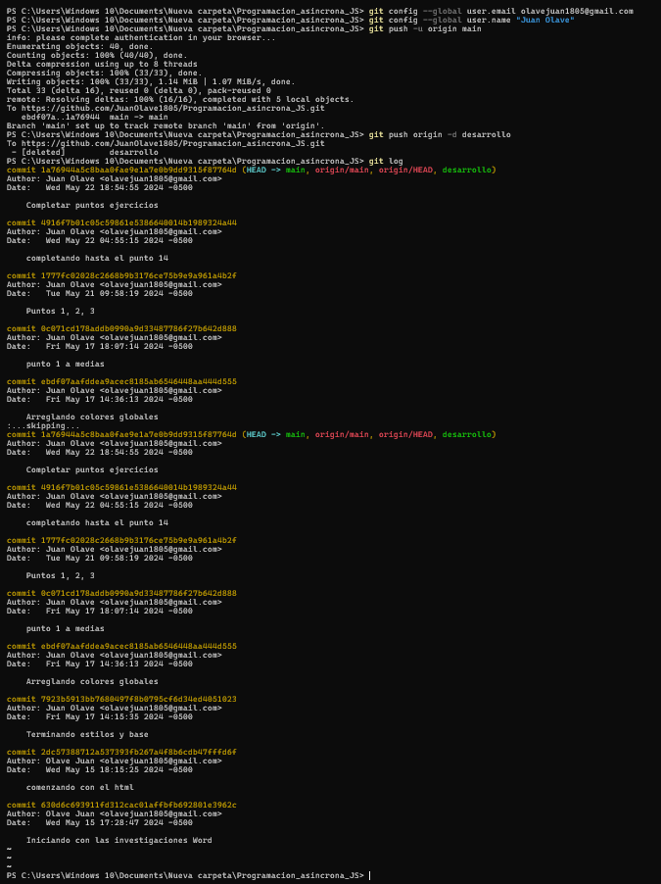

Link: https://juanolave1805.github.io/Programacion_asincrona_JS/